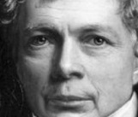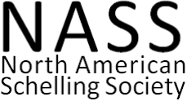
Schelling and Philosophies of the Earth

Sixth Annual Meeting of the North American Schelling Society

6-9 September 2018
University of Hawaiʻi at Hilo

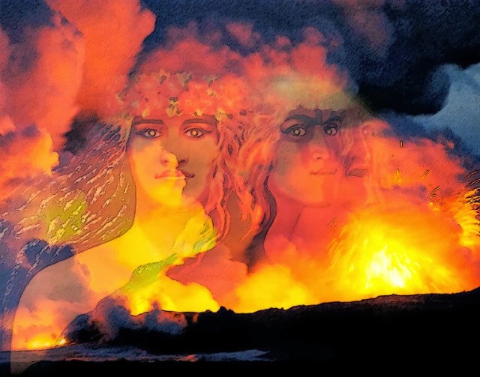

Thursday, September 6

8:30-9:00 Campus Center 301: Coffee and introductions

9:00-10:30 Campus Center 301: Positive and Negative Philosophies (Moderator: Tilottama Rajan)
Jason Wirth (Seattle University), “Freedom and the Earth: Reflections on the Relationship between Schelling’s Via Negativa and Via Positiva”
Kyla Bruff (Memorial University of Newfoundland), “The Late Schelling's Metaphysics as the Foundation of Adorno and Horkheimer's Philosophy of History”

10:45-12:15 CC 301: Schelling and Science (Moderator: Jason Wirth)
Violeta Aréchiga (UAM-Cuajimalpa), “Time and Historicity in The Ages of the World”
Tilottama Rajan (University of Western Ontario), “Schelling, Brown, and the Encyclopedization of Medicine”

2:00-3:30 CC 301: Nature and Creation (Moderator: Mark Thomas)
Nikolaj Zunic (St. Jerome’s University), “The Processes of Universio and Katabolé in the Creation of the World”

CC 306: Schelling in Hawaii (Moderator: Tim Freeman)
Steven Quevedo (University of Pittsburgh), “Hawaiian Nature Religion as Construction and Symbolization: A Problematic Test Case”
Chris Lauer (University of Hawaiʻi-Hilo), “The Last Living God: Reading Schellingʻs Philosophy of Mythology in Hawaii”

4:00-5:30 Wentworth 1: A Geology for Our Time (Moderator: Chris Lauer)
Joe Lawrence (College of Holy Cross), “Schelling's Transcendental Vulcanism and the Liberation from Solipsism”
Dale Snow (Loyola University Maryland), “Speculative Geology”

Friday, September 7

9:00-10:30 CC 301: Schelling in the Anthropocene (Moderator: Kristian Simcox)
Maximilian Hauer (Universität Leipzig), “Mit Schelling durch das Anthropozän”
Christina Pinsdorf (University of Bonn), "Ecology in the Anthropocene – Schelling and Humboldt as Pioneers of Environmental Humanities"

CC 306: Ceramics and Evil (Moderator: Jason Wirth)
Gabriel Reed (IDSVA), “Schelling’s Practice of Pyromenology: The Elemental Imagination of Fire in the Cretan Ceramic Revolution”
Adam Haaga (Memorial University of Newfoundland), “Evil by Analogy: Disease, Sickness, and Other False Strivings in Schelling’s Philosophy”

10:45-12:15 CC 301: Schelling and Contemporary Political Theory (Moderator: Kyla Bruff)
Johannes-Georg Schülein (Ruhr-Universität Bochum), “Schelling’s Political Naturalism”
Eliza Little (University of Chicago), “Against Enchantment: Monism and the Plutonic Point of View in Schelling’s Naturphilosophie”

CC 306: Landscapes (Moderator: Dale Snow)
Joan Steigerwald (York University), “Landscapes of Historical Experience”
Sakura Yahata (University of Tokyo), “Productive Nature of Landscape in Schelling’s Philosophy of Art”

1:45-3:15 CC 301: Religion in Schelling’s Turn (Moderator: Phoebe Page)
Alişan Genç (Memorial University of Newfoundland), “Eschatology and Political Theology in Schelling’s Stuttgart Lectures”
Sean McGrath (Memorial University of Newfoundland), “What is Positive About Negative Philosophy?”

3:30-5:00 CC 301: Dark Geological Forces (Moderator: Chris Lauer)
Carlos Zorilla (Emory University), “The Forge of this World: Natural Forces and Topological Functions in Schelling”
Lore Hühn (Albert-Ludwigs-Universität Freiburg), “On Nature: Schelling and Goethe in
Dialogue”

CC 306: Destruction and Extinction (Moderator: Charlotte Alderwick)
Ben Norris (The New School), “The Apoplexis of Pure Reason: Schelling and the Antinomy of Extinction”
Phoebe Page (Memorial University of Newfoundland), “Schellingian Evil as Anthropocentrism: Considering the Freiheitsschrift with Environmentalism”

Saturday, September 8

9:00-10:30 CC 306: Schelling and the Early Idealists (Moderator: Hannes Schülein)
Georg Spoo (Albert-Ludwigs-Universität Freiburg), „Schellings Kritik an Realismus, Idealismus und der Transzendentalphilosophie in seinen „Einleitungen“ zur Naturphilosophie (1797–1799)“
Daniel Smith (University of Memphis), “Schelling’s Contribution to the Kant-Reinhold Controversy”

10:45-12:15 CC 301: Freedom (Moderator: Joan Steigerwald)
Charlotte Alderwick (University of the West of England), “Schelling on the Nature of Freedom and the Freedom of Nature”
Juan Felipe Guevara-Aristizabal (Universidad Nacional Autónoma de México), “Nature and Freedom in Time”

12:30-1:45 Catered Lunch and Business Meeting

2:00-3:30 CC 301: Schelling’s Platonic Roots (Moderator: Joe Lawrence)
Gabriel Assumpção (Universidade Federal de Minas Gerais), “The Weltseele and the Plastic Arts”
Naomi Fisher (Clark University), “Schelling and the Philebus: The Unlimited in Nature”

3:45-5:15 CC 301: Logical Investigations (Moderator: Sean McGrath)
Mark Thomas (Central College), “The Twofold Meaning of Contingency in Schelling’s Freiheitsschrift”
Kristian Simcox (University of New Mexico-Gallup), “The Moral World of Nature: On the Prospect of a Schellingian Natural Education”

CC 306: Nature, Perception, and Technology (Moderator: Carlos Zorilla)
Jesús Emmanuel Ferreira González (Universidad Michoacana de San Nicolás de Hidalgo), “El filosofar que surge de la naturaleza. Una reflexión desde la filosofía de Schelling”
Marat Ocampo (Universidad Nacional Autónoma de México), “Schelling and the Technology of Nature”

Sunday, September 9
9:00-2:00 Naturforschung: Still to be determined. Meet at the Hilo Hawaiian

